Sprint Number 2

Members

Guy Dahan 208271734

Lior Elisberg 308032473

Mendel Amar 337790786

Eliran Dagan 208065180

Links

CircleCI: <https://app.circleci.com/pipelines/github/elirandagan/Project-Management-Personnel-Company?invite=true>

Heroku: <https://dashboard.heroku.com/apps/project-management-company>

GitHub: <https://github.com/elirandagan/Project-Management-Personnel-Company>

ClubHouse (Invitation): <https://app.clubhouse.io/invite-link/6050b3f7-a293-4ee7-bb7c-58c66e393258>

Website: <http://project-management-company.herokuapp.com>

**Functional Demands**

**Epic: Login/Sign up into The System**

**Contractor Worker**

1. When entering the system, the workers will be given a username and a password from the company, so that they could log in to the system.
2. When entering to the system, the workers would have the ability to get the username and password for the first time in the system by open the "First time here" modal.
3. When entering to the system, the workers would have the ability to get the username and password for the first time in the system by open the "First time here" modal by pressing the button "Click Here".
4. When entering the "First Time Here" Modal page, the worker will be had to fill in his personal ID for getting his username and password.
5. When entering the "First Time Here" Modal page, the worker will be had to click on "Get" after he fill in his personal ID for getting his username and password.
6. When clicking the "Get" button in the "First Time Here" Modal, the worker will get his username.
7. When clicking the "Get" button in the "First Time Here" Modal, the worker will get his password.
8. In the "First Time Here" Modal, the worker will have the ability to get back to the Login page.
9. In the "First Time Here" Modal, the worker will have the ability to get back to the Login page by clicking the "Login Page" button in the bottom of the Modal.
10. In the Login Page, the worker will have to choose "Contractor" checkbox.
11. In the Login Page, the worker will have to fill in his personal username in the label "username".
12. In the Login page, the worker will have to fill in his personal password in the label "password".
13. In the Login page, if the worker will fill in bad username/password, he will get a "wrong password/username label".
14. In the Login Page while entering the system, after filling the username and password, the user will be had to press the "Login" button to get in his Dashboard page system.

**Login/Sign up into The System – Contractor Worker – Test Cases**

|  |  |  |
| --- | --- | --- |
| Negative/Positive | Test case | # |
| Positive | Verify that when a contractor worker get username and password for the first time, he succeed login to the system. | 1 |
| Positive | Verify that when a contractor worker press on the "first time here" page by clicking the "Click Me" button, it opens the modal page. | 2 |
| Positive | Verify that when the contractor worker fill in his ID and press "Get" button, he will get the username and password. | 3 |
| Positive | Verify that when the contractor worker press on "Login Page", he returns to the landing login page. | 4 |
| Positive | Verify that when the contractor worker press "Contractor" check box and fill in his username and password, he get into the system | 5 |
| Positive | Verify that when the contractor worker fill in bad username/password, he wont be able to get in the system. | 6 |

**Human Resources**

1. When entering the system, the HR workers will be able to log into the system as an HR with their personal username and a password.
2. In the Login Page, the worker will have to choose "HR" checkbox.
3. In the Login Page, the HR worker will have to fill in his personal username in the label "username".
4. In the Login page, the HR worker will have to fill in his personal password in the label "password".
5. In the Login page, if the worker will fill in bad username/password, he will get a "wrong password/username label".
6. In the Login Page while entering the system, after filling the username and password, the user will have to press the "Login" button to get in his Dashboard page system.

**Login/Sign up into The System - Human Resources – Test Cases**

|  |  |  |
| --- | --- | --- |
| Negative/Positive | Test case | # |
| Positive | Verify that when an HR worker get username and password for the first time, he succeeds login to the system. | 1 |
| Positive | Verify that when an HR worker press "HR" check box and fills his username and password, he is redirected to the dashboard page | 2 |
| Positive | Verify that when the HR worker enters bad username/password, he won't be able to get in the system. | 3 |

**Other Employer**

1. As an employer, I would be able to log into the system by checking the “***Employer***” check box and typing a username and a password so I could use the system by clicking on the “***LOGIN***” button.
2. In the “***Log-in****”* Page, if the employer will fill in bad username/password, he will get a "***wrong password/username***” label.
3. In the “***Sign-up****”* Page, if the worker will fill in an invalid password, he will get an “***invalid password****”* label.
4. As an employer, I would be able to sign into the system using my first name, last name, ID number, company, username and password by clicking on the “**SIGN-IN**” button.
5. As an employer, in the “**Sign-up”** Page I would be able to return to the “**Log-in**” Page using the “**RETURN**” button.
6. In the “***Log-in****”* Page, if the employer will click on the “***LOGIN***” button when a field/s is/are missing, he will get a **proper sweat alert**.
7. In the “***Sign-in****”* Page, if the employer will click on the “**SIGN-IN**” button when a field/s is/are missing, he will get a **proper sweat alert**.
8. As an employer, after signing or logging in, I would be redirected to my **Dashboard** page system, so I could use the system.

**Login/Sign up into The System – Other Employer – Test Cases**

|  |  |  |
| --- | --- | --- |
| Negative/Positive | Test case | # |
| Positive | Verify that when the employer checks the "Employer" checkbox and fill in his username and password, clicks on the “LOGIN” button, he will enter into the system. | 1 |
| Positive | Verify that, in the "Login" page, when the employer checks the "Employer" checkbox and fill in a bad username and/or password, clicks on the “LOGIN” button, he will get a “wrong password/username” label. | 2 |
| Positive | Verify that, in the "Sign-up" page, when the employer enters a bad password, clicks on the “SIGN-IN” button, he will get an “invalid password” label. | 3 |
| Positive | Verify that, in the "Sign-up" page, when the employer enters a first and last name, ID, company, user name and a valid password, clicks on the “SIGN-IN” button, he will sign in and enter into the system, and be redirected to the dashboard page. | 4 |
| Positive | Verify that, in the "Sign-up" page, when the employer clicks on the “RETURN” button, he will be redirected to the “Log-in” Page. | 5 |
| Positive | Verify that, in the “Log-in” page, when the employer clicks on the “LOGIN” button, when a field/s is/are missing, he will get a proper sweat alert. | 6 |
| Positive | Verify that, in the “Sign-in” Page, when the employer clicks on the “SIGN-IN” button, when a field/s is/are missing, he will get a proper sweat alert. | 7 |
| Positive | Verify that as an employer, after signing or logging in, He would be redirected to the personal Dashboard page. | 8 |

**Epic: Dashboard Page**

**Contractor Worker**

1. In the Dashboard Page, the contractor worker will have the "Personal" Icon in the top-right corner (at the end of the Navbar).
2. The contractor worker would be able to see his Job rate.
3. The contractor worker would be able to see his job rate in the Dashboard page at top-left corner by the label "Rate".
4. By Clicking the "Personal" icon in the top-right corner, the contractor worker will have options to choose.
5. In the "Personal" icon option, the contractor worker will have the "Profile" option who leads to Profile page.
6. In the "Personal" icon option, the contractor worker will have the "Logout" option who leads back to Login page.
7. In the Dashboard Page, the contractor worker will have sidebar-navigation for moving from pages in the system.
8. In the sidebar-navigation pages. The contractor worker could choose the "Shifts" page.
9. In the sidebar-navigation pages. The contractor worker could choose the "Work History" page.
10. In the sidebar-navigation pages. The contractor worker could choose the "Absence" page.

**Dashboard Page – Contractor Worker - Test Cases**

|  |  |  |
| --- | --- | --- |
| Negative/Positive | Test case | # |
| Positive | Verify that when a contractor worker gets into the system, the "personal" icon is in the top-right corner(web). | 1 |
| Positive | Verify that when a contractor worker gets into the system, he could see his job rate in the left top corner. | 2 |
| Positive | Verify that when the contractor worker press on the "personal" icon he get to choose options. | 3 |
| Positive | Verify that when the contractor worker press pages in the sidebar-navigation, it leads him to chosen page. | 4 |

**Human Resources**

1. In the Dashboard Page, the HR worker will have the "Personal" Icon in the top-right corner (at the end of the Navbar).
2. By Clicking the "Personal" icon in the top-right corner, the HR worker will have options to choose.
3. In the "Personal" icon option, the HR worker will have the "Logout" option who leads back to Login page.
4. In the Dashboard Page, the HR worker will have sidebar-navigation for moving from pages in the system.
5. In the sidebar-navigation pages. The HR worker could choose the "Recruit" page to get access to the page.
6. In the sidebar-navigation pages. The HR worker could choose the "Tracking Workers" page to get access to the page.
7. In the sidebar-navigation pages. The HR worker could choose the "Statistics" page to get access to the page.

**Dashboard Page – Human Resources - Test Cases**

|  |  |  |
| --- | --- | --- |
| Negative/Positive | Test case | # |
| Positive | Verify that when an HR worker gets into the system, the "personal" icon is in the top-right corner(web). | 1 |
| Positive | Verify that when the contractor worker press on the "personal" icon he has the ability to choose options. | 2 |
| Positive | Verify that when the contractor worker press on the "personal" icon in the logout option he has the ability to get disconnected from the system. | 3 |
| Positive | Verify that when the contractor worker press pages in the sidebar-navigation, it leads him to chosen page. | 4 |

**Other Employer**

1. In the **Dashboard** Page, the employer will have the "***Personal***" Icon in the top-right corner (at the end of the Navbar).
2. By clicking the "***Personal***" icon in the top-right corner, the employer will be able to log-out of the system, by clicking on the “***LOGOUT***” button.
3. As an employer, after clicking on the “***LOGOUT***” button, I would be redirected to the “***Login****”* Page.
4. In the **Dashboard** Page, the employer will have a sidebar-navigation on the left side for moving through pages in the system.
5. In the sidebar pages, the employer could choose the "***Search worker***" page.
6. In the sidebar pages, the employer could choose the "***Hiring History***" page.
7. When **first** entering the system, the employer will be able to see the "***Hiring History***" in the Dashboard.

**Dashboard Page – Other Employer - Test Cases**

|  |  |  |
| --- | --- | --- |
| Negative/Positive | Test case | # |
| Positive | Verify that when an employer logs into the system, the "personal" icon is in the top-right corner (web). | 1 |
| Positive | Verify that when an employer clicks on the "Personal" icon in the top-right corner, he will be able to log-out of the system, by clicking on the “LOGOUT” button that appears. | 2 |
| Positive | Verify that when an employer clicks on the "Personal" icon in the top-right corner and then clicks on the “LOGOUT” button that appears, he would be redirected to the “Login” Page. | 3 |
| Positive | Verify that when an employer first logs into the system, he will be able to see the "Hiring History" page in the dashboard component. | 4 |
| Positive | Verify that when an employer first logs into the system, he will have a sidebar-navigation on the left side on the Dashboard component. | 5 |
| Positive | Verify that when the employer clicks on the "Search worker" in the sidebar-navigation, it leads him to "Search worker" page. | 6 |
| Positive | Verify that when the employer clicks on the "Hiring History" in the sidebar-navigation, it leads him to "Hiring History" page. | 7 |

**Epic: Profile User Page**

**Contractor Worker**

1. The contractor worker would be able to edit his profile to change his personal details.
2. The contractor worker would be able to see all his personal editable data in the profile page.
3. The contractor worker would be able to see his personal first name.
4. The contractor worker would be able to see his personal last name.
5. The contractor worker would be able to see his Area location.
6. The contractor worker would be able to see his Expertise.
7. The contractor worker would be able to see his personal description of part of a company.
8. The contractor worker would be able to edit his personal first name.
9. The contractor worker would be able to edit his personal last name.
10. The contractor worker would be able to edit his Area location.
11. The contractor worker would be able to edit his Expertise.
12. The contractor worker would be able to edit his personal description of part of a company.
13. The contractor worker would be able to save his changes by clicking the "Save" button at the bottom of the page.

**Profile User Page – Contractor Worker - Test Cases**

|  |  |  |
| --- | --- | --- |
| Negative/Positive | Test case | # |
| Positive | Verify that when a contractor worker gets into his profile page, he could see his personal details. | 1 |
| Positive | Verify that when a contractor worker gets into his profile page, he will be able to edit the details in his profile. | 2 |
| Positive | Verify that when the contractor worker wants to save his changes, while pressing the "Save" button the information will save and he will get a verify message on screen. | 3 |

**Epic: Worker Shifts Page**

**Contractor Worker**

1. The contractor worker would be able to report entering/exiting the shift so he can update his shifts state.
2. The contractor worker will have the ability to see all his upcoming shifts in the "Shifts Page".
3. The contractor worker will have the ability to see Shifts details.
4. The contractor worker will have the ability to see the date of the upcoming shift.
5. The contractor worker will have the ability to see who order him for the shift.
6. In the day of the shift, the contractor worker will have the ability to entering and exiting shift's time.

**Worker Shifts Page – Contractor Worker – Test Cases**

|  |  |  |
| --- | --- | --- |
| Negative/Positive | Test case | # |
| Positive | Verify that when a contractor worker gets into his "Shifts Page", he will see his upcoming shifts | 1 |
| Negative | Verify that when a contractor worker gets into his "Shifts Page", he will see his last shifts | 2 |
| Positive | Verify that when the contractor worker wants to enter shift or exit on his day of shift, he will be able to fill it. | 3 |
| Negative | Verify that when the contractor worker wants to enter shift or exit NOT on his day of shift, he will be able to fill it. | 4 |
| Positive | Verify that when the contractor worker will able to see the details of the upcoming shifts. | 5 |

**Epic: Work History View Page**

**Contractor Worker**

1. The contractor worker would be able to watch his work history, that will be divided into different categories.
2. The contractor worker would be able to watch his work history in the "Work History" page presenting in table.
3. The contractor worker would be able to see his pay for the hours he already did (the pay will be calculated for the entire month).
4. In the "Work History" table, the contractor worker would have the ability to see the dates he worked in the month.
5. In the "Work History" table, the contractor worker would have the ability to see who hired him in the month's shifts.
6. In the "Work History" table, the contractor worker would have the ability to see the starting time of the any shift in the month.
7. In the "Work History" table, the contractor worker would have the ability to see the ending time of the any shift in the month.
8. In the "Work History" table, the contractor worker would have the ability to see the total hours he worked for any shift in the month.
9. In the "Work History" table, the contractor worker would have the ability to see the salary he gained in any shift in the month.
10. In the "Work History" table bottom-row, the contractor worker would have the ability to see the total hours he worked in the month.
11. In the "Work History" table bottom-row, the contractor worker would have the ability to see the total salary he earned in the month.
12. In the "Work History" table bottom-row, the contractor worker would have the ability to see the total number of shifts he worked in the month.

**Work History View Page – Contractor Worker – Test Cases**

|  |  |  |
| --- | --- | --- |
| Negative/Positive | Test case | # |
| Positive | Verify that when a contractor worker gets into "Work History" page, all his information will represent in table. | 1 |
| Positive | Verify that when a contractor worker gets into "Work History" page, he could see in his bottom row table his total hours he worked. | 2 |
| Positive | Verify that when a contractor worker gets into "Work History" page, he could see in his bottom row table his total salary he earned. | 3 |
| Positive | Verify that when a contractor worker gets into "Work History" page, he could see in his bottom row table his total number of shifts he worked. | 4 |
| Positive | Verify that when a contractor worker gets into "Work History" page, he could see in table details of every single shift he made this month (hours, date, salary etc.) | 5 |

**Epic: Absence & Leaving Period Page**

**Contractor Worker**

1. The contractor worker would be able to report a leave period between specific dates, so he could not be hired on those dates.
2. In the "Absence Page" the contractor worker will have to fill in details about his period of leave.
3. In the "Absence Page" the contractor worker will have to fill in the specific date he starts his leave period.
4. In the "Absence Page" the contractor worker will have to fill in the specific date he ends his leave period.
5. By clicking the "Submit" button next to the labels he filled, the contractor worker will add the leave period to the "Future Absence".
6. In the "Absence Page", the contractor worker will have the ability to see his future absences he already filled in this month.
7. In the "Absence Page", the contractor worker will have the ability to remove his future absences he filled in this month.
8. In the "Absence Page", next to every component of absence, the contractor worker will have the ability to remove the specific absence by clicking the "remove" button.

**Absence & Leaving Period Page – Contractor Worker – Test Cases**

|  |  |  |
| --- | --- | --- |
| Negative/Positive | Test case | # |
| Positive | Verify that when a contractor worker gets into "Absence" page, he could see all his upcoming leaving periods. | 1 |
| Negative | Verify that when a contractor worker gets into "Absence" page, he could see all his past leaving periods. | 2 |
| Positive | Verify that when a contractor worker gets into "Absence" page, he could set a start date and ending date to his next upcoming leaving period. | 3 |
| Positive | Verify that when a contractor worker filled in the dates of leaving, he could save it by pressing the "Submit" button. | 4 |
| Positive | Verify that when a contractor worker submitted leaving period, the system verified it and shows the leaving period in the page. | 5 |
| Positive | Verify that when a contractor worker wants to delete specific upcoming leaving period, it disappeared from his page and he will get notification alert. | 6 |
|  | Verify when the contractor worker press on the "Remove" button next to specific component of absence, it will remove it from the system and he will be able to work in those dates. | 7 |

**Epic: Recruit & Adding New Workers Page**

**Human Resources**

1. The HR workers will have the ability to add a new contractor worker into the system (while filling all his personal details, his interests and his hourly pay).
2. The HR worker will have to fill the new worker's first name in the label "First name".
3. The HR worker will have to fill the new worker's last name in the label "Last name".
4. The HR worker will have to fill the new worker's ID in the label "ID".
5. The HR worker will have the option to fill the company the worker belongs to (if he does belong) in the label "Part of a company".
6. The HR worker will have to choose the new worker's expertise in the label " expertise ".
7. The HR worker will have to choose the new worker's expertise in a "Combo Box" that will present all the different categories of expertise.
8. The HR worker will have the option to choose from the " Combo Box " the expertise "Carpenter".
9. The HR worker will have the option to choose from the " Combo Box " the expertise "Plumber".
10. The HR worker will have the option to choose from the " Combo Box " the expertise "Painter".
11. The HR worker will have the option to choose from the " Combo Box " the expertise "Electrician".
12. The HR worker will have the option to choose from the " Combo Box " the expertise "AC Technician".
13. The HR worker will have the option to choose from the " Combo Box " the expertise "Gardener".
14. The HR worker will have to fill the new worker's hourly payment in the label "Hourly Payment".
15. The HR worker will have to fill the new worker's username in the label "Username".
16. The HR worker will have to fill the new worker's password in the label "Password".
17. The HR worker will be able to save his changes by clicking the "Create" button at the bottom of the page.

**Recruit & Adding New Workers Page – Human Resources – Test Cases**

|  |  |  |
| --- | --- | --- |
| Negative/Positive | Test case | # |
| Positive | Verify that when an HR worker gets into the recruit page his has the ability to add a new contactor worker by adding his details | 1 |
| Positive | Verify that when the HR worker will not fill all the necessary fields he will get an error message on screen | 2 |
| Positive | Verify that when the HR worker will choose the expertee of the contactor worker a combox box will appear with all the options. | 3 |
| Positive | Verify that the HR worker won't be able to add a new contactor worker with a username already used. | 4 |
| Positive | Verify that the HR worker won't be able to add a new contactor worker with a password with under than 6 characters. | 5 |
| Positive | Verify that when the HR worker wants to save his changes, while pressing the "Save" button the information will be saved and he will get a verify message on screen. | 6 |

**Epic: Tracking Workers Page**

**Human Resources**

1. The company will have the ability to monitor the contractor workers attendance clock according to the workers details, and in addition, to report mistakes, such as working days that are missing entering time, and to make the necessary changes.
2. The HR worker will have to fill the new worker's ID in the label "Worker ID".
3. The HR worker will be able to search for the worker by clicking the "Search" button at the right of the worker id label.
4. The HR worker will be able to see all the worker's details below the worker Id label after clicking on the "Search" button.
5. The company would have the ability to monitor the hiring that were made.
6. The system will present all the workers hiring history in a table so that the HR worker could monitor the hiring.
7. The system will present into the worker details the "Date" the worker was added by an HR worker.
8. The system will present into the history table the "Date" the company hired the worker in the label "Date".
9. The system will present into the history table the "Company" the company that hired the worker on this day in the label "Company".
10. The system will present into the history table the beginning of the shift the worker was hired into the field "From".
11. The system will present into the history table the beginning of the shift the worker was hired into the field "To".
12. The system will present into the history table the total hours of the shift the worker was hired into the field "Total".
13. The system will present into the history table the Salary of the shift the worker was hired into the field "Salary".
14. The system will present into the history table, the option for the HR worker to report for an error in a shift.
15. The HR worker will have the option to report shift's errors by clicking on the "Report" button at the right of the shift.
16. The HR worker will have the option to change shift's beginning hour by clicking on the pen into the field he wants to change.
17. The HR worker will have the option to change shift's ending hour by clicking on the pen into the field he wants to change.

**Tracking Workers Page – Human Resources - Test Cases**

|  |  |  |
| --- | --- | --- |
| Negative/Positive | Test case | # |
| Positive | Verify that the HR worker could see all the contractor workers attendance clock according to his details | 1 |
| Positive | Verify that when the HR worker enters an incorrect worker ID and click on the button search he gets an error message on screen | 2 |
| Positive | Verify that the HR worker could report for missing details in a shift by clicking on the button report at the right of the line | 3 |
| Positive | Verify that the HR worker will be able to see all the shifts the contractor worker did in a table | 4 |
| Positive | Verify that the HR worker will be able to change shift beginning hour by clicking on the pen into the field he wants to change. | 5 |
| Positive | Verify that the HR worker will be able to change shift ending hour by clicking on the pen into the field he wants to change. | 6 |

**Other Employer**

1. As an employer, I would be able to **search** for a contract worker based on different options:

1. As an employer, I would be able to search for a contract worker based on **field of expertise**, such as “Carpenter”, “Plumber”, “Painter”, “Electrician”, “A.C. technician” and “Gardener”.

1. As an employer, I would be able to search for a contract worker based on the worker’s **rate** – (from 1 to 5).
2. As an employer, I would be able to search for a contract worker based on the **date** that I need the worker.
3. As an employer, I would be able to search for a contract worker based on the worker’s **range of hourly payment**. (min to max).
4. As an employer, I would be able to search for a contract worker based on the worker’s **living area** (South, North, and Center).
5. As an employer, I would be able to **clear** the search by clicking on the “***CLEAR***” button.
6. As an employer, I would be able to **activate** the search filter by clicking on the “***SEARCH***” button.
7. After clicking on the “***SEARCH***” button, the employer would be able to see the all the relevant searches, organized in a chart.
8. As an employer, after searching, I would be able to see available contract workers’ **first names**.
9. As an employer, after searching, I would be able to see available contract workers’ **last names**.
10. As an employer, after searching, I would be able to see available contract workers’ **field of expertise**, so I can choose workers that are suitable for what I am looking.
11. As an employer, after searching, I would be able to see available contract workers’ **rates**, so I can choose workers that have the best rating.
12. As an employer, after searching, I would be able to see available contract workers’ **hourly payment**, so I can choose workers that are affordable to me.
13. As an employer, after searching, I would be able to see available contract workers’ **area of living**, so I can choose worker that are close to me.
14. As an employer, after searching, I would be able to **book** any available worker that is shown in the chart, by clicking on the “***BOOK***” button.

**Tracking Workers Page – Other Employer - Test Cases**

|  |  |  |
| --- | --- | --- |
| Negative/Positive | Test case | # |
| Positive | Verify that when an employer makes a search, and then clicks on "CLEAR" button, all the fields in the search component will be cleared from previous text.  The current search table will still be displayed. | 1 |
| Positive | Verify that before filling on of the fields in the search component, the "CLEAR" button will be disabled for the employer. | 2 |
| Positive | Verify that when an employer fills in one (or more) of the search fields , and then clicks on the “SEARCH” button, the search table component will be re-rendered and will display the valid & matched searches in the table component. | 3 |
| Positive | Verify that after a valid search was made, when an employer clicks on “Rate” label for the **first time**, the table would be sorted by **descending** order of rates of each contract worker that appears in the table component. | 4 |
| Positive | Verify that when an employer clicks on “Rate” label for the **second time**, the table would be sorted by **ascending** order of rates of each contract worker that appears in the table component. | 5 |
| Positive | Verify that when an employer fills in the “Rate” field with "4 and above", and then clicks on the “SEARCH” button, the search table component will be re-rendered and will display the valid & matched contract workers that are rate with "4 and above". | 6 |
| Positive | Verify that when an employer fills in the “Expertise” field with "Plumber", and then clicks on the “SEARCH” button, the search table component will be re-rendered and will display the valid & matched contract workers that are expertise as "Plumber". | 7 |

**Epic: Statistics About the System Page**

**Human Resources**

1. The system will present into a graph the numbers of hiring that were made each day from the beginning of the month.
2. The system will present into a graph the numbers of hiring by expertise that were made each day from the beginning of the month.
3. The system will present into a graph the numbers of other employers that signed up to the company each day from the beginning of the month.

**Statistics About the System Page – Human Resources - Test Cases**

|  |  |  |
| --- | --- | --- |
| Negative/Positive | Test case | # |
| Positive | Verify that the HR worker enter the statistics page he can see a graph with the numbers of hiring that were made each day from the beginning of the month. | 1 |
| Positive | Verify that the HR worker enter the statistics page he can see a graph with the numbers of hiring by expertee that were made each day from the beginning of the month. | 2 |
| Positive | Verify that the HR worker enter the statistics page he can see graph with the numbers of other employers that signed up to the company each day from the beginning of the month. | 3 |

**Epic: Hiring History Page**

**Other Employer**

1. As an employer, I would be able to see the **monthly** hiring history that has been made in a chart, organized by different field :
2. As an employer, I would be able to see all the **names** of contract workers that were hired this month.
3. As an employer, I would be able to see all the **dates** of contract workers that were hired this month.
4. As an employer, I would be able to see all the **starting hours** of contract workers that were hired this month.
5. As an employer, I would be able to see all the **ending hours** of contract workers that were hired this month.
6. As an employer, I would be able to see the **total hours** of each contract worker that were hired this month.
7. As an employer, I would be able to see the **total payment** of each contract worker that were hired this month.
8. As an employer, I would be able to **modify** the **starting hour** of an individual contract worker, by clicking on the “**pencil**” button at the right side of that worker’s row.
9. As an employer, I would be able to **modify** the **ending hour** of an individual contract worker, by clicking on the “**pencil**” button at the right side of that worker’s row.
10. As an employer, I would be able to see the **total amount of contract workers** that has been hired in current month.
11. As an employer, I would be able to see the **total amount of payment** that has been made.
12. As an employer, I would be able to see **the monthly hiring history** that has been made in a chart, sorted by **NAME**- by clicking on the “Worker Name” label.
13. As an employer, I would be able to see the **monthly hiring history** that has been made in a chart, sorted by **DATE**- by clicking on the “Date” label.
14. As an employer, I would be able to see the **monthly hiring history** that has been made in a chart, sorted by **LOCATION** - by clicking on the “Location” label.
15. As an employer, I would be able to see the **monthly hiring history** that has been made in a chart, sorted by **STARTING HOUR**- by clicking on the “From” label.
16. As an employer, I would be able to see the **monthly hiring** **history** that has been made in a chart, sorted by **ENDING HOUR**- by clicking on the “To” label.
17. As an employer, I would be able to see **the monthly hiring** **history** that has been made in a chart, sorted by **TOTAL HOURS**- by clicking on the “Total” label.
18. As an employer, I would be able to see the **monthly hiring history** that has been made in a chart, sorted by **PAYMENT**- by clicking on the “Payment” label.

**Hiring History Page – Other Employer – Test Cases**

|  |  |  |
| --- | --- | --- |
| Negative/Positive | Test case | # |
| Positive | Verify that when an employer clicks on "pencil" button of a listed contract worker, he would be able to edit the starting/ending hour of that shift in the opened modal by typing the new hours. | 1 |
| Positive | Verify that the employer is able to see the valid total amount of payment that has been made. | 2 |
| Positive | Verify that the employer is able to see the valid monthly hiring history that has been made in a chart. | 3 |
| Positive | Verify that when an employer clicks on “Total” label for the **first time**, the table would be sorted by **descending** order of total hours of each hiring that were made. | 4 |
| Positive | Verify that when an employer clicks on “Total” label for the **second time**, the table would be sorted by **ascending** order of total hours of each hiring that were made. | 5 |
| Positive | Verify that when an employer clicks on “Payment” label for the **first time**, the table would be sorted by **descending** order of total payment of each hiring that were made. | 6 |
| Positive | Verify that when an employer clicks on “Payment” label for the **second time**, the table would be sorted by **ascending** order of total payment of each hiring that were made. | 7 |

**Non-Functional Demands**

**Epic: Responsive System Abilities**

1. The System will be so the users could use the system in various platforms.
2. The system will support using with smartphones so the users could use the system with more mobility.
3. The system will support using web computers so the users could enjoy the system to his comfort.
4. The system will have a login landing page that will be suitable for all entities in the system.

**Responsive System Abilities – Test Cases**

|  |  |  |
| --- | --- | --- |
| Negative/Positive | Test case | # |
| Positive | Verify that when entering the website using smartphones, none of the abilities and the features the site offers will disappeared. | 1 |
| Negative | Verify that when entering the website using computers web, none of the abilities and the features the site offers will disappeared. | 2 |
| Positive | Verify that when the entering the URL of thee site, the landing page is the "Login Page". | 3 |

**Epic: Security**

1. The System will support security page by adding SSL key to make sure the system is safe for the user.
2. The system will support authentication request to DB collections to make sure that the user will get his right abilities and information.

**Security – Test Cases**

|  |  |  |
| --- | --- | --- |
| Negative/Positive | Test case | # |
| Positive | Verify that when entering the website, it has an SSL Key (https). | 1 |
| Negative | Verify that there are different collection of users in the DB, each for any utility. | 2 |

**Epic: Flexibility of the System**

1. The system will support different browsers.
2. The system will support "Chrome" browser.
3. The system will support "Edge" browser.
4. The system will support "Safari" browser.

**Flexibility of the System – Test Cases**

|  |  |  |
| --- | --- | --- |
| Negative/Positive | Test case | # |
| Positive | Verify that when entering the website using "Chrome" browser, none of the abilities and the features the site offers will disappeared. | 1 |
| Negative | Verify that when entering the website using "Edge" browser, none of the abilities and the features the site offers will disappeared. | 2 |
| Positive | Verify that when entering the website using "Safari" browser, none of the abilities and the features the site offers will disappeared. | 3 |

**Explanations & Screen Shots**

In our project, we decided that our site would be more like an "information system". Each entity defined in our system: Contractor Worker, Human Resources and other employer, will have monitors of the system (the monitors will be relatively similar), each entity and its authority and its functionality (for each entity we created labels in "ClubHouse" also for "Functional" & "Non-Functional").

All of our requirements were uploaded to our "ClubHouse" Project (link in the top of the doc), so as our epics of the different pages for any entity so as similar logics.

To sort out the requirements (which we had to implement as well as write), we decided to divide the system into several monitors that combine several requirements with a common denominator and make it more convenient for each entity to perform actions (requirements) in parallel.

The landing page of our system is the login page. This is a page that is relevant to any entity that would like to use the system. On this page you can select which entity you want to use the system, as well as actions that are relevant to each entity. For example: If this is my first time in the system as a contractor, I would like to get my username and password and this will have a unique button and model that will provide the information to the contractor.

Once logged in each entity is taken to the Dashboard Page, and each entity will have sidebar navigation where each entity can choose where it wants to route in the system (as mentioned at the beginning, the division into different pages and similar logics).

**Landing Page (Login Page):**

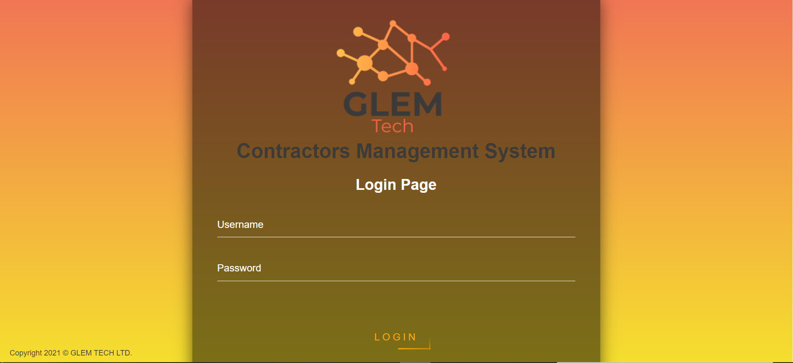

**Dashboard Page for example:**

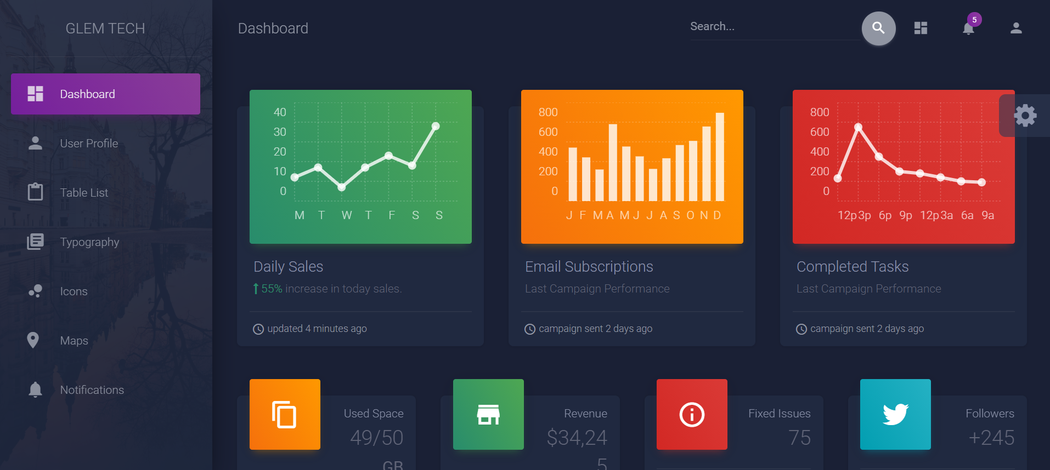

**Conventions**

We decided to go on clear and "easy" conventions, only double quotes.

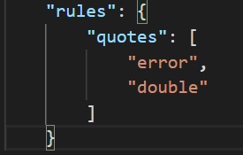

**Tools**

In this project, we were asked to use and choose CICD tools as well as database.

**CI: "CircleCi"**

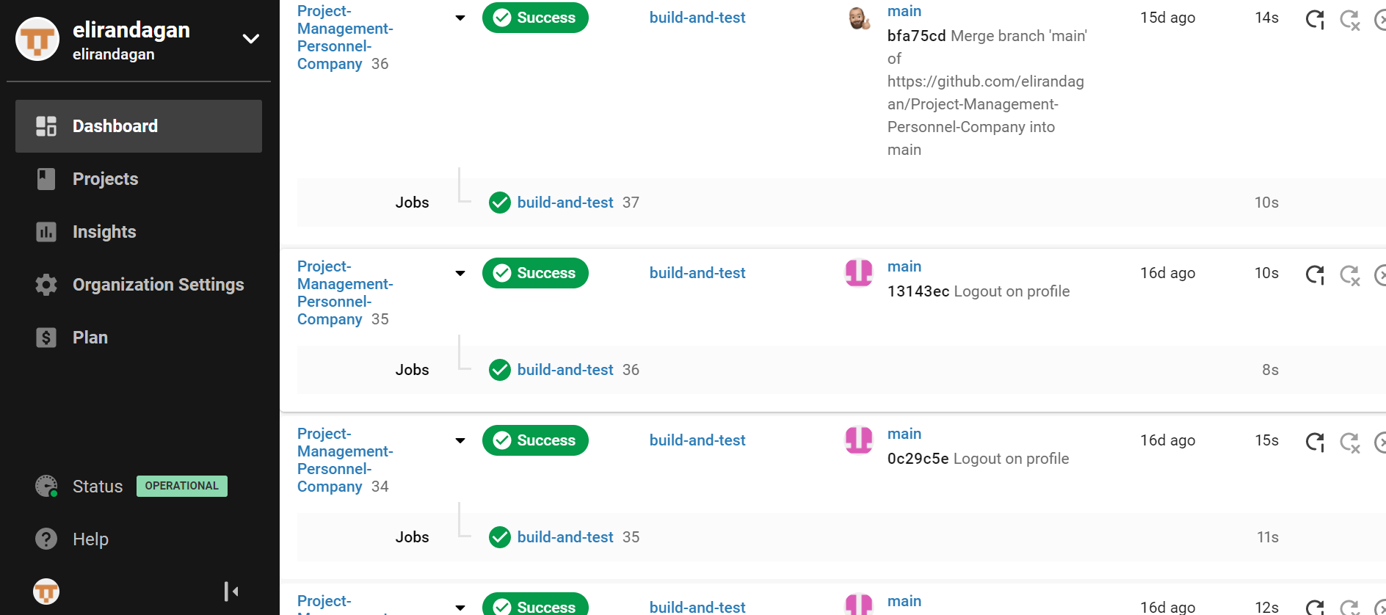

**Cloud Server (CD): "Heroku"**

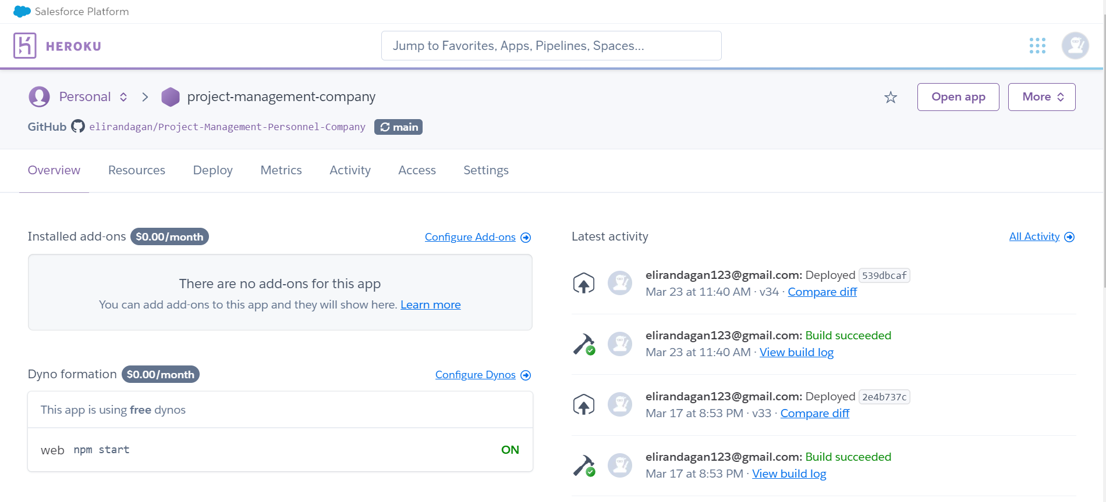

**Database: "MongoDB"**

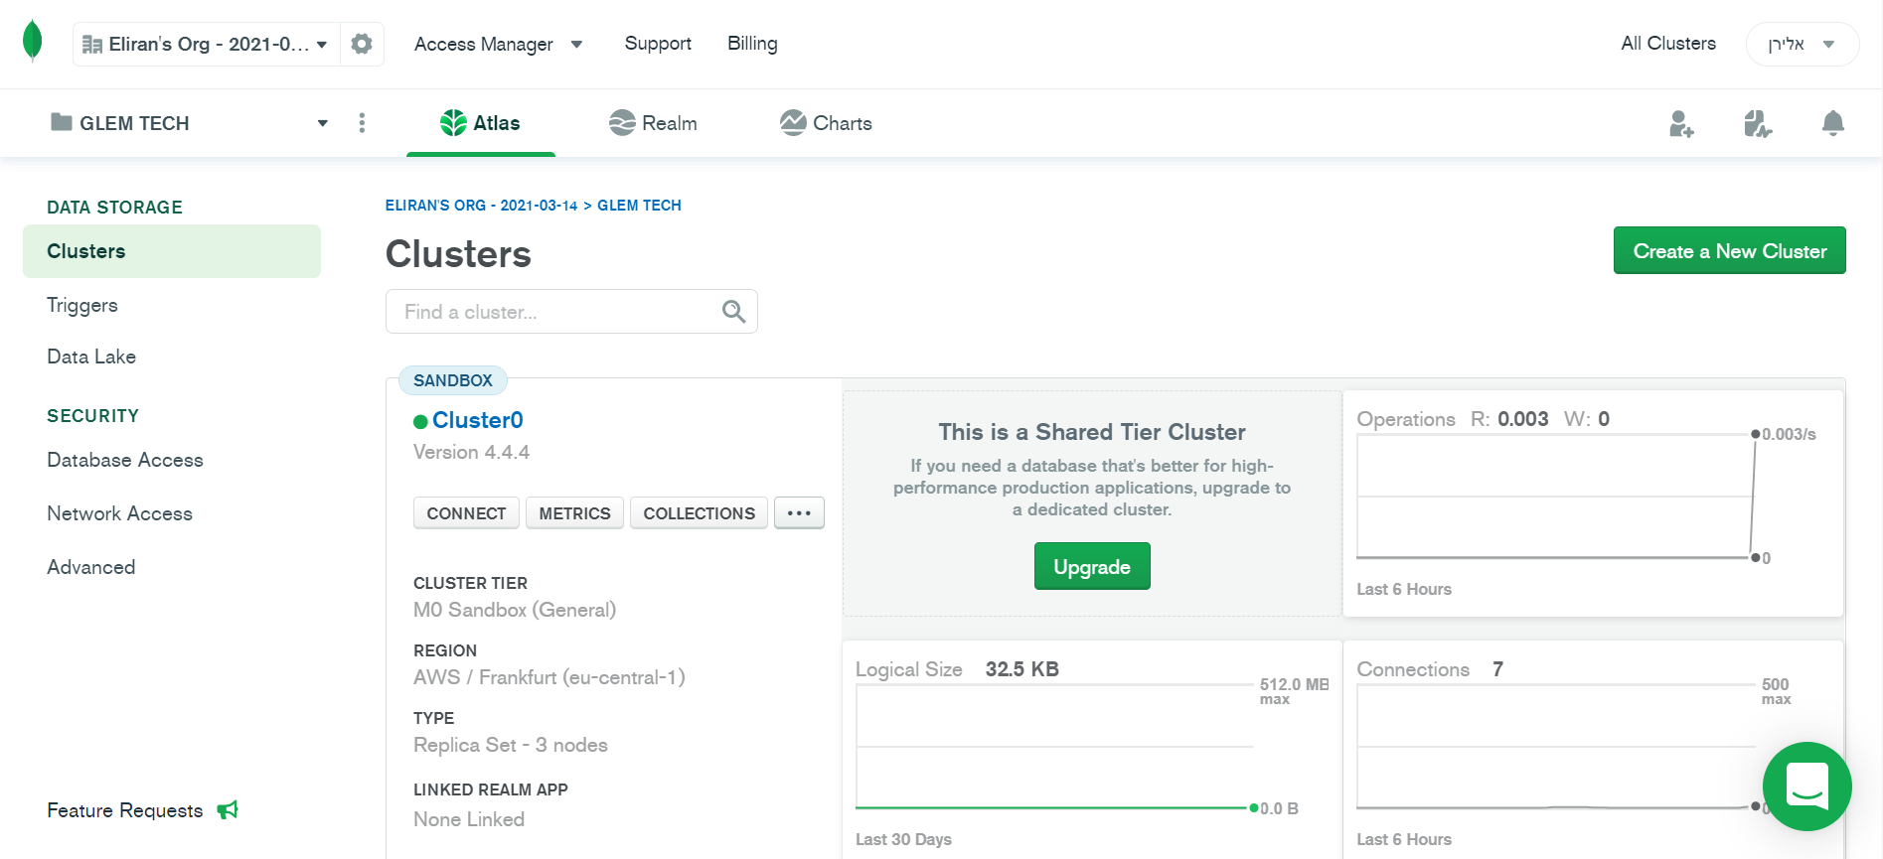

**Division for Sprints**

|  |  |
| --- | --- |
| Sprint 3 (number of requirements) | Sprint 4 (number of requirements) |
| Epic: Login/Sign up into the system (28) | Epic: Worker Shifts Page  (6) |
| Epic: Dashboard Page (24) | Epic: Work History View Page (12) |
| Epic: User Profile Page (13) | Epic: Absence & Leaving Period Page  (8) |
| Epic: Responsive System Abilities (4) | Epic: Hiring History Page (12) |
| Epic: Security (2) | Epic: Tracking Workers Page  (28) |
| Epic: Flexibility of the System (4) |  |
| Epic: Recruit & Adding New Workers Page (17) |  |
| Epic: Statistics About the System Page (4) |  |